

**GITAM Bengaluru Campus, NH 207, Nagadenahalli Doddaballapura**

**Taluk, Bengaluru Rural District-561203**

**“MOBILE SIGNAL JAMMER”**

**Sri Sagar A**

**2024203703**

**MTech in VLSI Design**

**Technical Seminar**

Mobile Signal Jammer

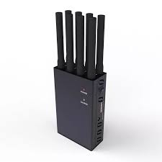

Figure Mobile Signal Jammer

* What is Mobile Signal Jammer?
* A mobile signal jammer is a device that blocks cellular communication by transmitting interfering radio signals.
* Why it is used?
* Interference: They block cellular communication by emitting radio frequency signals that disrupt mobile phone signals.
* Localized Effect: They create a "dead zone" where mobile phones cannot receive or transmit signals.
* Variable Legality: Their use is heavily regulated or illegal in many countries, with exceptions for specific authorized uses.
* Security Applications: They are used in military, law enforcement, and security settings to prevent communication for security reasons.
* Potential for Abuse: They can be misused for criminal activities or disrupt public communication.
* What the applications of Mobile Signal Jammer?
* Blocks cellular signals via radio frequency interference.
* Creates a localized "dead zone" for mobile phones.
* Legality is highly restricted in most regions.
* Used in security and military applications.

Table of Contents

List of Figures 4

List of Table 5

1. Introduction 6

2. Working Principle 6

3. Construction and simulation 6

o RF Amplifier 6

o Tuned oscillator 6

o Noise producing capacitors 6

4. Circuit Design and Component Selection 7

5. Real-Time Applications 8

6. State of Art 9

7. Applications (Restricted to Authorized Use): 10

o Security Operations: 10

o Law Enforcement: 10

o Defence: 10

o Examinations & Meetings: 10

8. Advantages: 10

o Simple Design: 10

o Low Cost: 10

o Wideband Disruption: 10

o Learning Tool: 10

9. Legal and Ethical Considerations 11

10. Limitations 11

Conclusion 11

# List of Figures

Figure 1 Mobile Signal Jammer 2

Figure 2 Schematic of Mobile Signal Jammer 6

Figure 3 Output of Mobile Signal Jammer 7

# List of Table

Table 1 Jamming Technology Table 9

# Introduction

• A Mobile Jammer is a device which used to fail or disturb any communication system.

• Mobile Jammer produces a noise frequency range similar to the communication frequency range which tend to add the noise to the communication frequency.

# Working Principle

• Usually your mobile phone communication works on some range of frequencies. When in these frequencies same range of frequency noise is get added then mobile communication fails or get disturbed.

• When we add such range of frequencies in mobile communication using any circuit then that circuit is called Mobile Jammer.

• Assume if some applications are working on 445MHz frequency range and you add same range of frequency noise then those applications will not work correctly.

# Construction and simulation

The Mobile Jammer circuit is mainly made up of three circuits:

## RF Amplifier

- RF Amplifier is made up of capacitors, transistor and resistor and which is used to amplify the signal and noise signal produced by capacitors.

## Tuned oscillator

-Tuned oscillator produces high frequency with less damping.

## Noise producing capacitors

- Noise producing capacitors produces the noise signal which will get add in communication frequency range.

NI Multisim Pro Edition is a robust electronic circuit simulation tool with a user-friendly interface and extensive component libraries. It enables diverse simulations, including analog, digital, and mixed-signal, for thorough circuit analysis. The Pro Edition offers advanced simulation models and enhanced PCB integration, reducing prototyping costs. Its interactive features facilitate learning and accelerate design cycles, providing accurate and efficient circuit development. It is a valuable tool for both educational and professional electronic design.

# Circuit Design and Component Selection

The circuit employs a simple oscillator design based on a BJT NPN transistor (2N3707) and a network of capacitors and inductors to generate a wide range of frequencies.

* Transistor (2N3707): This NPN BJT acts as the active element in the oscillator circuit. Its characteristics, such as current gain and frequency response, are crucial for the circuit's performance.
* Capacitors (2.2pF, 4.7pF, 14pF, 102pF, 103pF, 1µF, 4.7µF): These capacitors, with varying values, are utilized to create a resonant network that determines the oscillation frequency and bandwidth. The wide range of capacitor values aims to generate a broad range of frequencies.
* Inductor (21nH): The inductor, in conjunction with the capacitors, forms the resonant tank circuit, influencing the oscillation frequency.
* Resistors (100Ω, 39kΩ): The resistors are used for biasing the transistor and controlling the current flow within the circuit.
* DC Power Supply (4V): This provides the necessary power to operate the circuit.

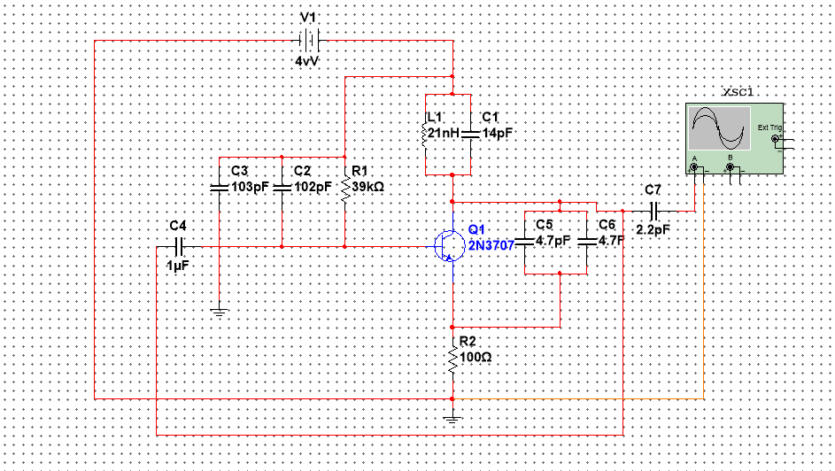

Figure Schematic of Mobile Signal Jammer

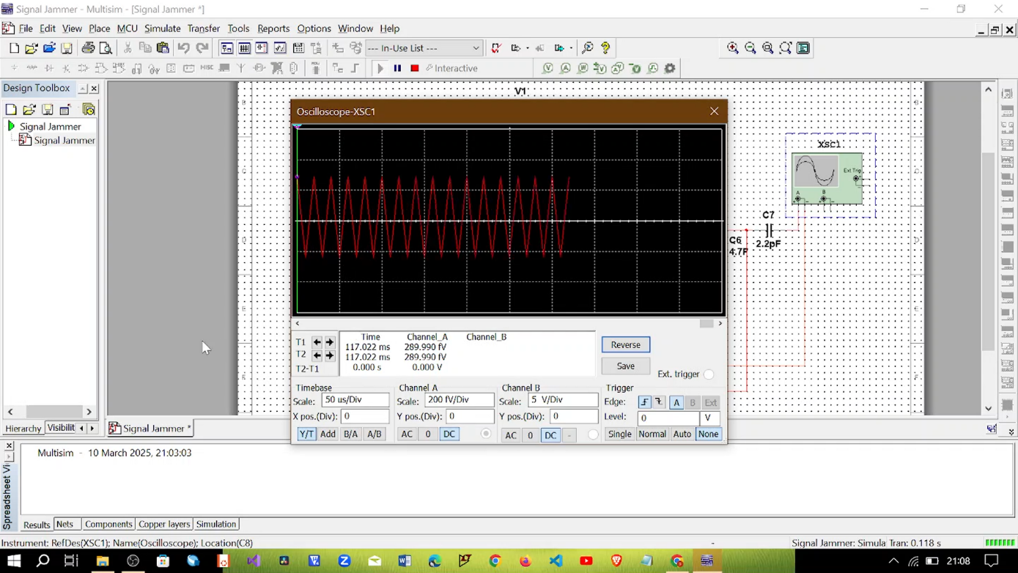

Figure Output of Mobile Signal Jammer

# Real-Time Applications

* Security Applications: In controlled environments, such as secure testing facilities, this type of circuit could be used to prevent unauthorized wireless communication.
* Testing and Development: During the development of wireless devices, a simple noise generator can be used to simulate interference and test the device's resilience.
* Educational Purposes: This circuit provides a practical demonstration of oscillator principles and RF interference.
* Controlled environment signal blocking: In areas where cell phone usage is prohibited, such as theaters, or sensitive meeting rooms.

# 

# State of Art

|  |  |  |  |  |
| --- | --- | --- | --- | --- |
| Technology/Method | Description & Mechanism | Period | Price Range (INR - Approximate) | Effect/Range |
| Early Analog Jammers | Simple oscillators, wideband noise. | 1990-1995 | ₹5,000 - ₹20,000 | Limited, 5-10 meters |
| Selective Frequency Jammers | Targeted frequency blocking, specific bands. | 1995-2000 | ₹20,000 - ₹50,000 | Moderate, 10-20 meters |
| Multi-Band Jammers | Blocks multiple GSM/CDMA bands simultaneously. | 2000-2005 | ₹50,000 - ₹1,50,000 | Significant, 20-50 meters |
| Programmable/Software-Defined Jammers | Software-controlled, adaptable frequency blocking. | 2005-2010 | ₹1,50,000 - ₹5,00,000+ | Variable, 50-100+ meters |
| Drone/Portable Jammers | Compact, mobile jammers for specific operations. | 2010-2015 | ₹1,00,000 - ₹3,00,000 | Moderate, 10-30 meters |
| High-Power/Directional Jammers | High output, focused signal blocking. | 2015-2020 | ₹3,00,000 - ₹10,00,000+ | Extensive, 100+ meters |
| 5G/Advanced Band Jammers | Blocks latest mobile communication bands. | 2020-2025 | ₹50,000 - ₹20,00,000+ | Variable, depending on tech. |
| Mobile Signal Jammer | Oscillator using 2N3707, LC circuit, wideband noise. | 2020-2025 | ₹500 - ₹2,000 (components) | Very Limited, 1-5 meters (estimated) |

Table Jamming Technology Table

# Applications (Restricted to Authorized Use):

## Security Operations:

* + Disrupting communication during sensitive operations (e.g., counter-terrorism, hostage situations).
  + Preventing remote detonation of explosive devices.
  + Controlling communication within secure facilities.

## Law Enforcement:

* + Jamming mobile signals during raids or arrests.
  + Preventing communication among suspects.

## Defence:

* + Disrupting enemy communication during military operations.
  + Protecting sensitive military installations.

## Examinations & Meetings:

* To prevent cheating during examinations.
* To prevent information leaks during important meetings.

# Advantages:

## Simple Design:

* Relatively easy to construct with basic electronic components.

## Low Cost:

* + Components are inexpensive, making it a low-cost solution (in terms of component cost).

## Wideband Disruption:

* + Potentially disrupts a broad range of mobile frequencies (though not reliably).

## Learning Tool:

* + Can be used to study the principles of RF oscillation and signal jamming (in controlled educational settings).

# Legal and Ethical Considerations

* It is crucial to emphasize that the use of signal jammers is strictly regulated and often illegal in many jurisdictions. Unauthorized use can result in severe penalties.
* This circuit should only be used for educational or testing purposes in controlled environments.

# Limitations

* Limited range and power output.
* Lack of frequency control and stability.
* Susceptibility to interference from other RF sources.
* The circuit is very basic, and will not jam modern encrypted signals.

# References

* <https://youtu.be/rdrK8qqeL0k?si=1PqvLg_j0c98M0bs>
* <https://github.com/SriSagarA/Mobile-Signal-Jammer.git>

# Conclusion

This report has detailed the design, operation, and analysis of a Mobile Signal Jammer circuit. While the circuit offers a simple and low-cost approach to generating RF noise, its limitations in range, stability, and control must be acknowledged. Compared to other jammer types, such as white noise jammers, sweeping jammers, and digital jammers, this basic circuit provides a fundamental understanding of RF interference. It is essential to understand and adhere to all applicable laws and regulations regarding the use of signal jammers. Compared to state-of-the-art jammers, which leverage advanced digital technologies, this basic circuit provides a very rudimentary level of jamming.